Procurement Management
- Importance
- Make or buy decision
- Types of contracts
- Procurement cycle

Procurement Management
- The acquisition of products or services not produced or delivered by the project team
- May require the assistance of experts
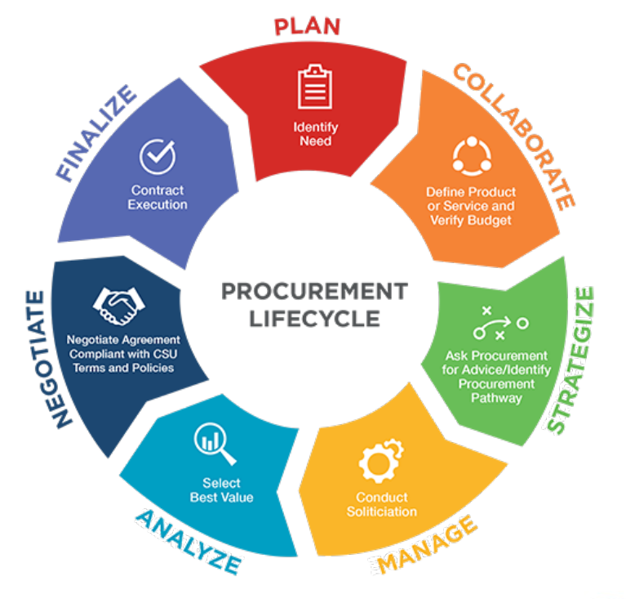
- Your project may be on the other side also—providing services to another organization
- Legal implications of signing a contract
- The make-or-buy decision
  - Expertise
  - Resource availability
  - Licensing, regulatory requirements
- Fixed Price
- Cost reimbursable
- Time and materials

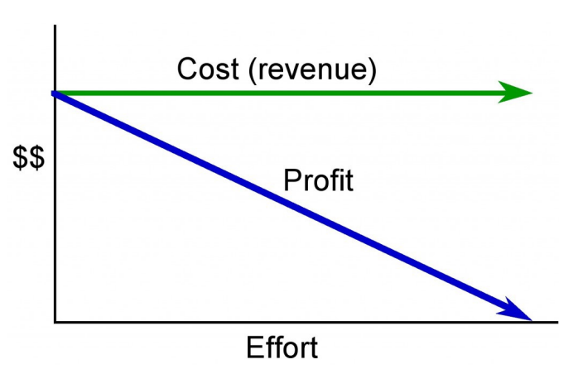
Fixed Price Contract

Fixed-price contract the cost is constant regardless of the effort applied or the delivery date

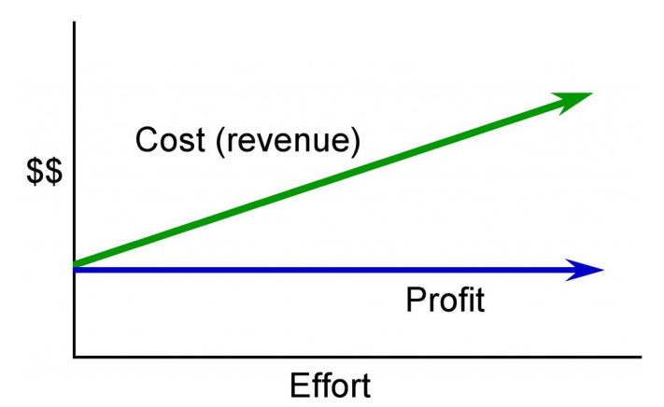
Cost Reimbursable Contract

In a cost-reimbursable or cost-plus contract,
the seller is guaranteed a fee

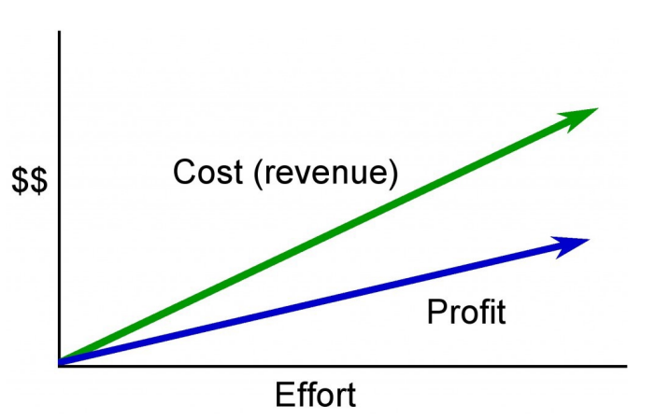
Time and Materials

In a time and materials contract the cost
(or revenue to the vendor) increases
with increased effort

Fixed Price Contract types
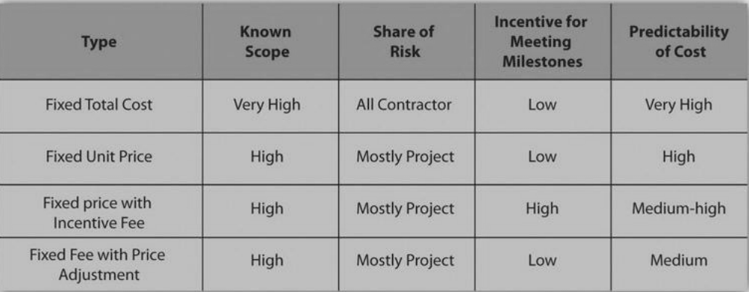

Cost-Reimbursable Contract Types
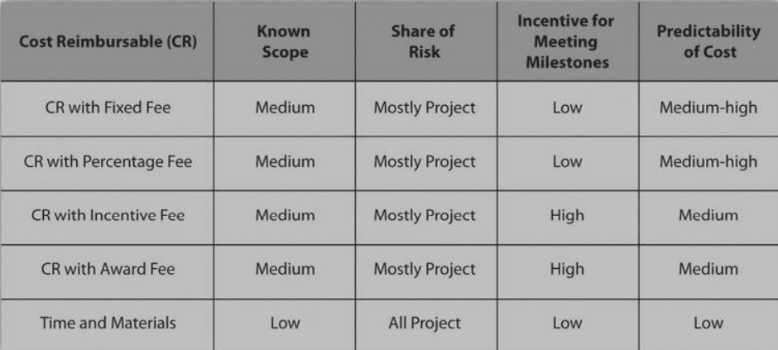

Procurement Cycle
- Procurement Plan
- Selecting the Contract Approach
  - Skill level, uniqueness
  - Type of relationship: supplier, vendor, partnership
  - RFP, RFQ, personal contact
  - How well-known is the scope of the work?
  - Risks—what are they? Who assumes them?
  - How much float if any?
  - How important to be sure of cost in advance?
- Soliciting bids
- Qualifying bidders
- Request for Quote (RFQ)
- Request for Proposal (RFP)
- Evaluating the bids
  - Usually a matrix approach
  - Cost is NOT the only consideration
- Awarding the contract
- Managing the contracts
- Logistics and expediting
- Change coordination

Procurement Management Summary
- Make or buy analysis
- Contract types
  - Fixed Price
  - Cost reimbursable
  - Time and materials
- The Procurement Cycle
  - Bidder qualification
  - RFP or RFQ
  - Analysis and selection
  - Contract negotiation
  - Contract administration
  - Contract closure

Chapter Summary
- Procurement is an important activity for project managers
- Procurement management includes deciding about contracts and relationships with vendors, suppliers, partners
- All stages of procurement should be closely monitored
- Reporting to the team and to management are important components in budget and procurement management

